**Login Testing**

1. **Login Collection**

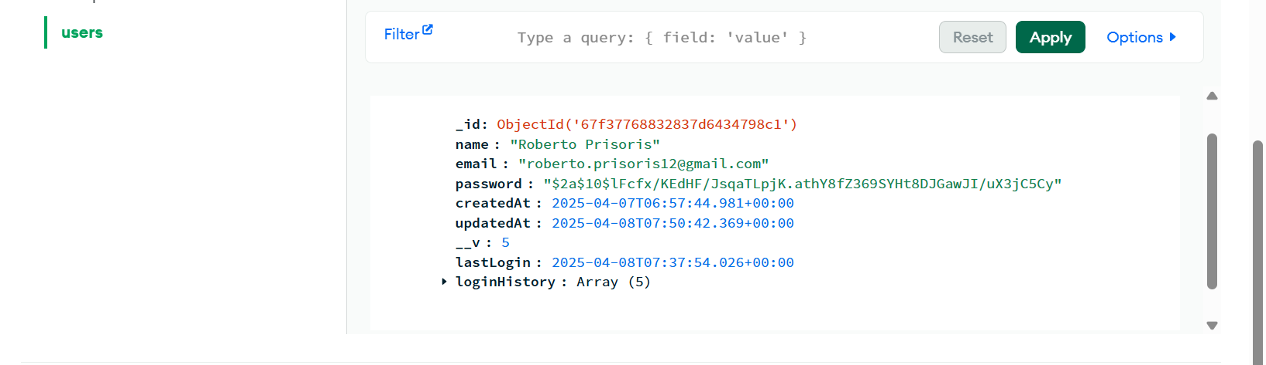

1. **Initial Login Screen**

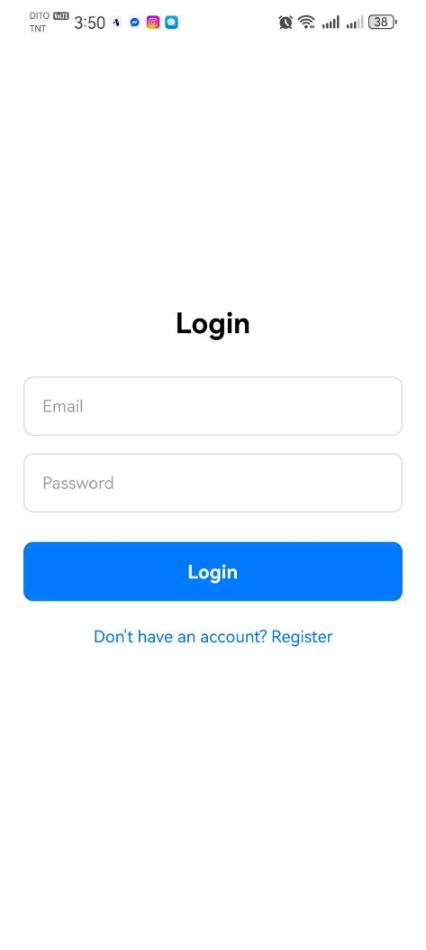

1. **Testing Failed Login**

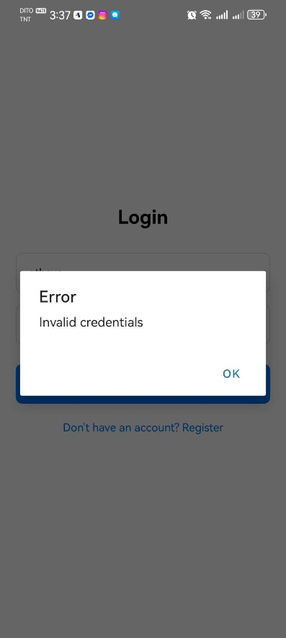

* 1. **There are no changes after the login failed**

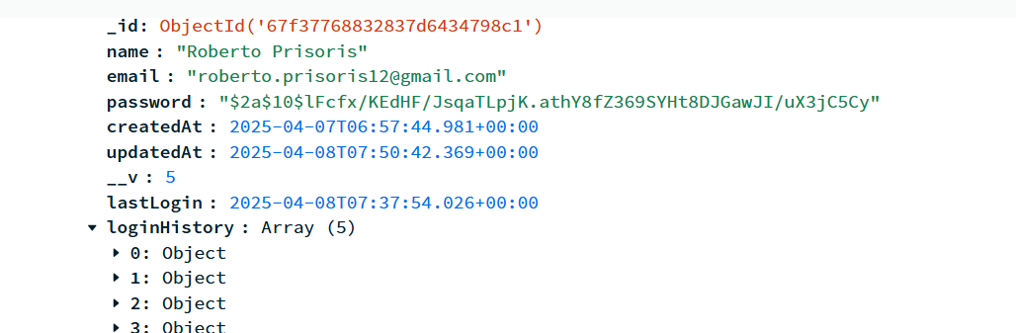

1. **Testing Successful Login and Logout**

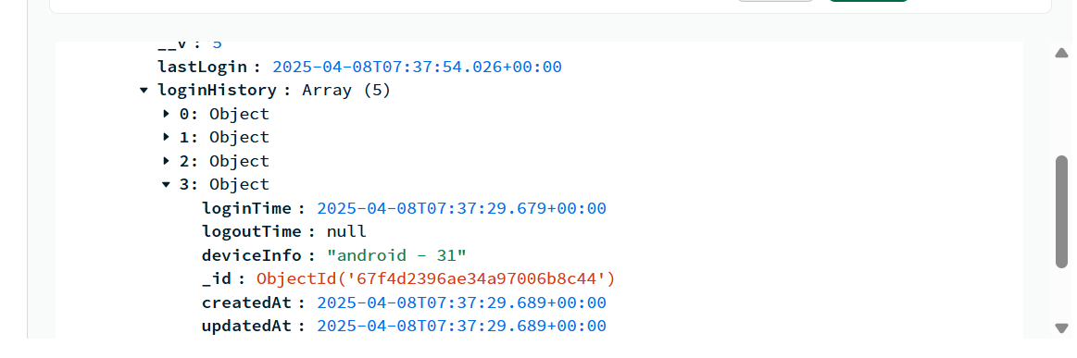

* 1. **It will go directly to Dashboard after Successful Login**

